
Wiltshire Community Web Online Newsletter

February 2007

Hello all and welcome to the fourth issue of the bi-monthly Wiltshire Community Web Online Newsletter.

Two hundred sites on WCW! Hooray!!
Since launching in April 2006, over 200 sites have now been set up on the 3 new district areas of Wiltshire Community Web (excluding South Wilts).
Over 800 sites can be found on WCW across all 4 districts.
Thank you all for supporting this new initiative and making WCW the success that it has become.
A BIG thank you to all from WCW!

Training Events Information

The first series of free training events has now been completed. The second will commence in the Spring/Summer time. These will be for both for the new and advanced users of WCW.

All dates will be advertised in future newsletter issues and in the news and diary sections of www.wiltshirecommunityweb.org.uk – keep checking back!

If you are a group of people that are interested in finding out more about WCW, we could organise a group training session – get in contact!

Hints and Tips

Don’t forget…Online Tutorials!
Don’t forget that the online tutorials are there to help you make the most of your WCW site.
The tutorials cover everything from the very basics of registration and setting up your site right through to using advanced features like setting up mailing lists, adding news, jobs and diary items and even using some simple HTML to enhance the look of your pages.
A link to the WCW Tutorial can be found on each district home page.

News and Diary Modules

Do you have news or events for your local area that you want to share?
Maybe you’re holding an event that is open to the public?

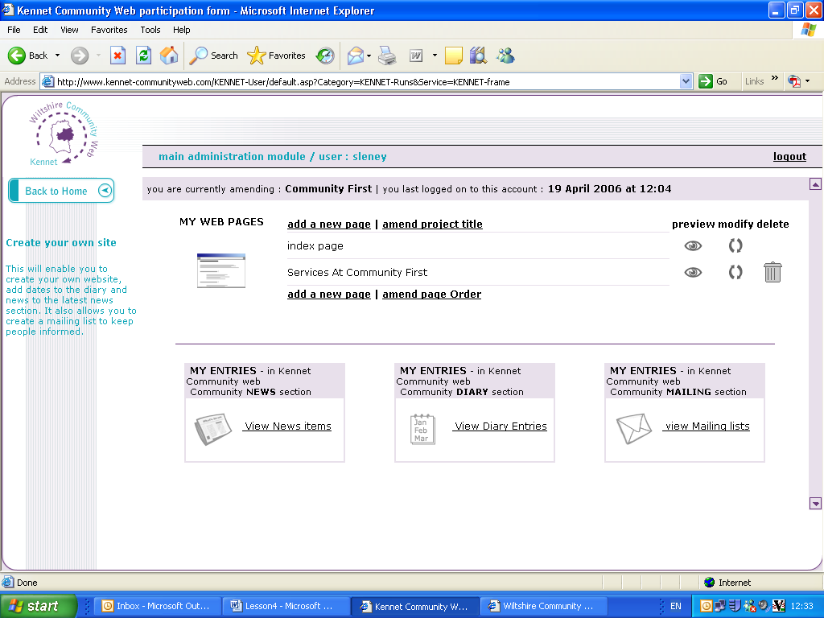
Now that you are a registered user of WCW, why not make use of the News and Diary facilities of your district site. Adding and managing news and diary items can be done through your admin page (as shown below).
Admin Page
For more information, take a look at Lesson 5 and 6 of the WCW Tutorial.

New Diary Template Launched December 06
The 3 new districts of WCW now have a new template for you to incorporate into your own WCW site.
The Diary template is available as one of the eight different templates that you can choose from to build your WCW pages.
You can add up to twelve different events that can be displayed on your own WCW site and entered automatically onto the ‘What’s On’ section for the entire district site.
Jobs

Do you have a job to advertise for your local area?

Then why not make use of the jobs module for your district site. This facility is for all registered users to advertise paid or voluntary jobs that are available within the local area.

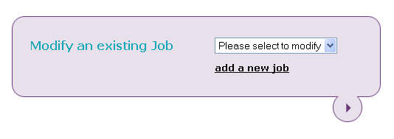
Adding and managing jobs can be carried out from the screen that follows login.

Further information can be found in Lesson 7 of the WCW Tutorial.

Spotlight on a Wiltshire Community Web Site

JB Jewellery and JellyBelly JellyBrain

“I am the sort of person who thinks modern-technology is great and should be embraced.... however, not everybody feels the same.

Most of us accept that computers and the "interweb" are here to stay, especially given most of our primary school children take it all for granted, but isn't it just a bit scary to learn new things?

No! Not when most of the work has been done for you. Yes, it may take a slightly different way of thinking, but we all have to start somewhere.

I have created 2 of my own personal websites from scratch without a single scrap of knowledge about html, code, frontpage and any other jargon phrases you can think of. Admittedly, it took a steep learning curve, but with a bit of determination (and bravery) I got there.

I wanted to promote my services locally as well as nationally as I also feel it's important to support local businesses and crafts-people. With that in mind, I posted links on Wiltshire Community Web.

So if you want to have a go at getting an internet presence, my advice is to start with something simple and easy to follow..... Wiltshire Community Web!”
Emma Canham
Visit the sites on Wiltshire Community Web:
http://www.northwilts-communityweb.com/site/JB-Jewellery/index.htm

http://www.northwilts-communityweb.com/site/jellybelly-jellybrain/index.htm

Get your site noticed!

For each newsletter, we will feature a site that has been created on Wiltshire Community Web.

If you would like to have your site featured here in a future issue to promote your success, then get in touch!

Email us at info@wiltshirecommunityweb.org.uk with a short explanation of your site.

Editors Notes

Wiltshire Community Web is managed by Community First.

Community First is a charitable organisation that works at the forefront of community development to help improve the quality of life and economic well being of people and local communities throughout Wiltshire and Swindon

For further information visit our website at www.communityfirst.org.uk

Community First
Wyndhams
St Josephs Place
Devizes
Wiltshire
SN10 1DD Tel: 01380 722475 Fax 01380 728476
Charity Registration Number: 288117
Company Limited by Guarantee Registration Number: 1757334

